WITNESS AT THE BORDER
 & 

For Immediate Release

January 12, 2020: “Witness at the Border” to Shed Light on Humanitarian Crisis, Violence Against Women & Family Separation Caused by “Remain in Mexico” (MPP)

A “Campaign With No End” Demands Due Process & Asylum Rights

Hundreds of Activists from 30 States Join with ACLU-TX in Brownsville, Texas

What: WITNESS AT THE BORDER launches a high-profile, long-term vigil challenging US immigration policy.
1) We will protest the injustice of the rigged tent courts and demand restoration of asylum. 2) Participants will also cross the Gateway International Bridge linking Brownsville, Texas to Matamoros, Tamaulipas, Mexico to observe and report on the conditions in the refugee camps.

The vigil will not end until the “Remain in Mexico” (MPP) policy is repealed and due process and asylum rights restored. Solidarity events in Albany, NY; Florida; New Hampshire; Northern California; Ohio; Virginia, more.

Where: Xeriscape Park, corner of E. Elizabeth St. and International Blvd., Brownsville, Texas

When: The Vigil Begins Sunday, January 12, 2020
9 am - Gather at Xeriscape Park
10 am - Picketing at the Tent Courts
Noon - Rally (program to be announced)
2:30 pm - Crossing Gateway International Bridge to Witness in Matamoros, Mexico
After January 12: Daily Vigils
February 14: SAVE THE DATE for “Love, Not Hate” Witnessing event at the border.

Who: Tornillo/Homestead immigration activist Josh Rubin and witnesses who helped close child detention centers in Texas and Florida. ACLU Texas. Endorsed by Children's Defense Fund-TX. Members of Don’t Separate Families, Grannies Respond/Abuelas Responden Inc., Rio Valley Relief Project and Americans from Texas and at least 30 other states, including clergy and congregants, educators, health professionals, lawyers, and immigrant rights groups. (Interviews available.)

Images: * Protesters near Tent Courts, with ACLU Texas.* Crossing the bridge into Matamoros MX to bear witness.* Migrants and asylum seekers. * Banners by artist Alessandra Mondolfi (see attached jpegs) that say “MPP Has Created a Humanitarian Crisis,” etc.

What’s Different: Humanitarian relief at the border is vital, yet not enough. Tears are not enough--we need outrage. Witness at the Border demands an end to cruel policies that corrupt our legal system and force people to live in dangerous and degrading circumstances. Activists will sustain a presence at the border until the policy of MPP is reversed and asylum rights are restored. Witness at the Border calls on elected officials and all those horrified by what is being done in our name to come and see for themselves.

Background: Since MPP was instituted, an estimated 60,000 migrants and asylum seekers (plus thousands more asylum seekers waiting in Mexico due to the US policy known as “metering”) are trapped on the Mexican side of the border. International observers and anecdotal evidence indicate a high level of violence against young girls and women, abductions, rape, extortion. Family separation continues, albeit out of sight of most Americans.

Media Contacts
• Joshua Rubin, Witness at the Border founder, 917-693-9676
• Imelda Mieja, ACLU Texas, 346-299-6803, media@aclutx.org
• Camilo Perez Bustillo, Ctr for Advanced Study in Behavioral Sciences, Stanford Univ., 937-951-5911
• Karla Barber, Witness at the Border Texas team, 214-729-4870, witnessmpp@gmail.com
• Thomas Cartwright, Global Refugee Advocate, 614-208-2791,Thcartwright@gmail.com

#EndMPP #WitnessAtTheBorder #RestoreAsylum #WelcomeRefugees

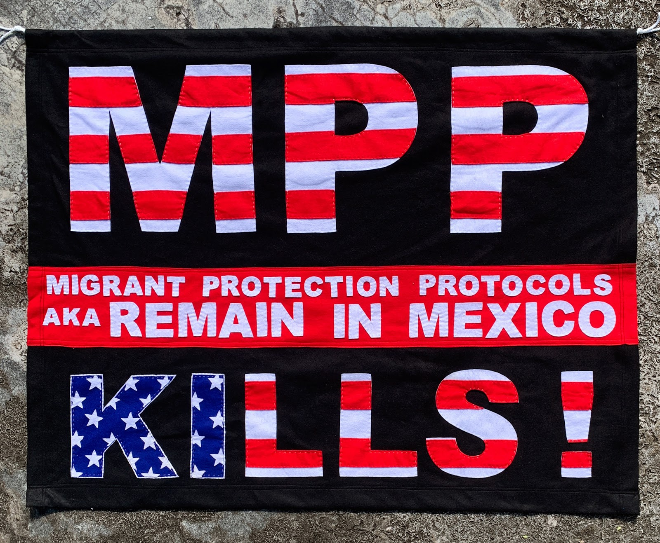

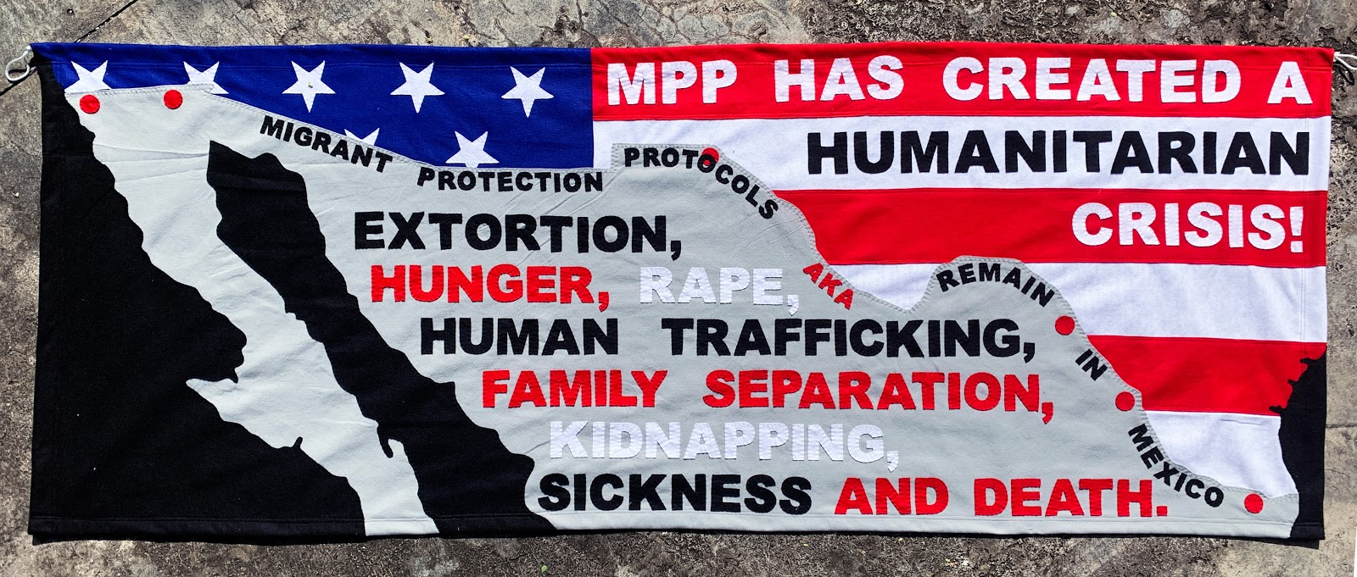
“Banner art by Alessandra Mondolfi at Witness at the Border Vigil launching January 12, 2020 to decry the injustice of Remain in Mexico policy.”

